**System Architecture**

The architecture provides the top level design view of a system and provides a basis for more detailed design work. Draw a system architecture diagram.

This section provides a high level overview of the structural and functional decomposition of the system. Focus on how and why the system was decomposed in a particular way rather than on details of the particular components. Include communications and information on the major responsibilities and roles the system (or portions) must play.

For the high-level architecture design, we applied the client-server, publish-subscribe, and repository architectural styles. Client-server architectural style is used to illustrate the interaction between the client and server components that is meant to improve the system’s modularity.

The client presentation would represent the application for specific personnel namely administration, HR, managers, and employees. Each of the client presentations and applications represent each type of user interface and the specific actions and functions that each user can accomplish. For instance, the employee user interface will not be the same as the HR user interface as HR personnel have the ability to override actions whereas employees do not.

While the server components are used for the server-side presentation and business logic. Specifically the web servers would involve the authentication system, request access system, and the notification system. For the authentication system it would handle connecting to the existing intranet portal system and utilize the portal’s single-sign-on mechanisms for user authentication. The request access system that handles the process of accessing previous requests, creating future requests, and creating forms for certain requests. The notification system that handles request approval and status changes. Additionally, the application would have a rules-based system that is used for validating and verifying leave time requests.

Meanwhile, the system would utilize the publish-subscribe architectural style specifically for the system design of the notification system as it involves interacting with the employee and managers. Additionally, employees, managers, and HR should receive request status changes in real-time. This will help connect the notification system server and all of the client applications.

Finally, the system design also encompasses the repository architectural style because of the several databases utilized by the application. One database is the activity log database that would keep track of the transactions. Another database is the requests database which handles all the information relating to any requests made. Another database is the Employee database that has employee information. Finally, there is the Authentication database that contains the personnel login-in information that allows access through the portal system’s single sign-on mechanism.

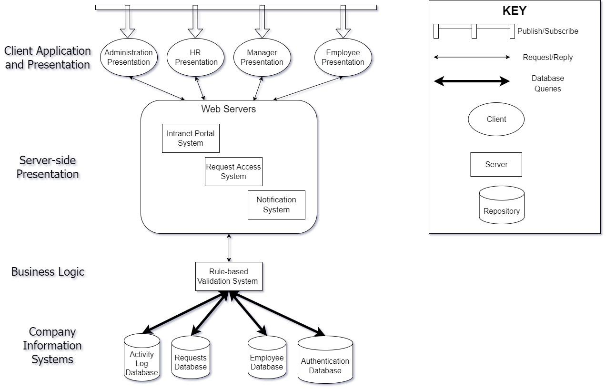

**Figure ?. High-Level System Architecture Diagram**

Reliability is the probability of the software executing without failure for a specific period of time. Reliability issues can occur because of improper inputs, errors in the code itself, components that are not available when needed, and hardware failures. This is a major design issue relevant to the project as the system must be able to run with little to no failure as it is a system used by countless personnel (employees and managers) and must be able to deal with risk management. For instance, minimizing data loss in case of failure and limited communication occurring in the workplace due to workload.

Reusability is the indicator of the relative effort required to convert a software component to other applications. Reusability issues can occur due to modularity, documentation, the environment, and capability.

Maintainability is the ease at which a software’s code is understood, repaired, or enhanced. Maintainability issues can occur in the system due to incorrect documentation and no refactoring. This is another major design issue relevant to the project as the system should be able to be understood, enhanced, and repaired as it is used to help streamline the functions of the HR department and must be understood as the desired functionality must be considered in the context of any existing or proposed systems.

Testability is the ease at which a system or system unit can be tested and verified. The system can experience testability issues due to the requirements, subsystem, or other components not being verified as acceptable or not resulting in many unresolved faults and malfunctions.

Performance represents the responsiveness of the system to various inquiries and actions. For this system, performance would involve the response time for the queries to display results. Additionally, the system performance aspects include data capacity (Maximum amount of data stored in a database), dynamic capacity (Maximum number of concurrent users of the system), and latency (the amount of time it takes for the data to be processed). Performance issues the system can experience are imprecise response time and latency. This is another major design issue as the system must be able to meet requirements in a timely fashion. The system response time should not take longer than 10 seconds. People using this system are busy people and they can get frustrated.

Portability is the measure of effort needed to migrate software from one operating environment to another. Portability issues can occur due to what portions of the product are movable and localized as well as what platforms need support which affects the environment.

Security deals with blocking unauthorized access to system functions or data, ensuring that the software is protected from malware attacks. Security issues can arise due to the internet opening issues like malware, phishing, and denial of service. This is another major design issue as the system must be able to protect against unauthorized access to the application and its data. For instance, the system should not compromise or hinder the security of the existing authentication portal system. Security is important due to the several servers and databases.

Safety deals with the need to prevent a system from doing any injury to people or damage to the property. Safety issues can occur due to the system not following business rules.